WRE Bulletin 1st

WRE's -Finnish MTBO Championship Sprint, 22/5, 2021
WRE's -Finnish MTBO Championship Long, 23/5, 2021:

Welcome to the Finnish MTB-O Championships in Espoo, Finland, 22–23 April 2021

Event organizers – Event website

Espoon Suunta - https://espoonsuunta.fi/tapahtumat/sm-pyorasuunnistus-2021/

Race officials

Event director – Pasi Laaksonen
Course setters – Emil Laaksonen, Lauri Hollo and Harri Hollo
Results service – Ville Kokkila
Event secretary and contact person (also in English) – Kari-Pekka Seppänen
email. karipekka.seppanen@espoonsunta.fi tel. +358503311443
IOF-Event Adviser – Arto Voutilainen
Technical adviser – Mikko Niskanen
Course controller – Mika Rantala (HS)

Competition rules

This event follows the rules of the Finnish Orienteering Federation, the IOF guidelines for World Ranking
Events, the special rules for the Finnish Championships, and the instructions given by the organizers. The
rules of the Finnish Orienteering Federation and the special rules for the Finnish Championships are
available at the website https://www.suunnistusliitto.fi/kilpailu/saannot-ja-ohjeet/lajisaannot/ (only in
Finnish).

Punching system

The electronic punching system Emit-tag will be used. Rental Emit-tag cards are available from the event organizer, fee 5 €. If the rental Emit-tag card is not returned after the competition, there will be a charge of 100 €.

Classes

The H21 (=M21) and D21 (=W21) classes have WRE status in both races. Estimated winning times for women are in sprint 25 minutes and in long 110 minutes. For men in sprint 25 minutes and in long 110 minutes. Finnish MTB-Orienteering Championships take place at the same time with classes from H/D15 to H/D85 in both races. There totally about 300 orienteers in the competition.

Entries and entry fees

The entry fee for the WRE classes (per race) is 39,20 €. Entry and payment no later than Thursday 13 of April 2021. No late entries allowed.
Entries and payments should be made primarily through the IRMA system of the Finnish Orienteering Federation, https://irma.suunnistusliitto.fi. Include your Emit-tag card number in your entry. If your card number is missing, the organizers will reserve a rental Emit-tag card for you at a 5 € fee. Rental Emit-tag cards should be picked up and paid at the information desk at the competition centre.
Foreign competitors without access to IRMA enter through IOF Eventor. The new IOF World Ranking system only uses the Latin alphabet from a to z. It is very important for all runners to check that the information about them is correct. Please check the following: the spelling of your first and last name, your nationality and your year of birth. If you find any mistakes, please report them to changes_AthleteData@orienteering.org. When reporting, make sure you indicate your complete date of birth (day, month, year). It is not possible to pay through IOF Eventor.

The bank details for entry fee payment without IRMA

Account owner: Espoon Suunta ry.
Bank name: Nordea Bank Abp
Bank address: Satamaradankatu 5, 00020 Nordea, Finland
IBAN: FI05 1112 3000 3168 41
BIC: NDEAFIHH
Payments are accepted in euros only. Please indicate the names of the competitors in the message field of
the payment form.

IOF ID

WRE athletes have to include their IOF IDs in their entry. Athletes who do not yet have an IOF ID will get
one by registering a user account in IOF Eventor: https://eventor.orienteering.org/Register.

Event venue

The event venue for both races is Vanttila school - Nissintie 2, 02780 Espoo. Parking will be organized next to school.

Embargoed areas

The embargoed area is indicated on the map below:
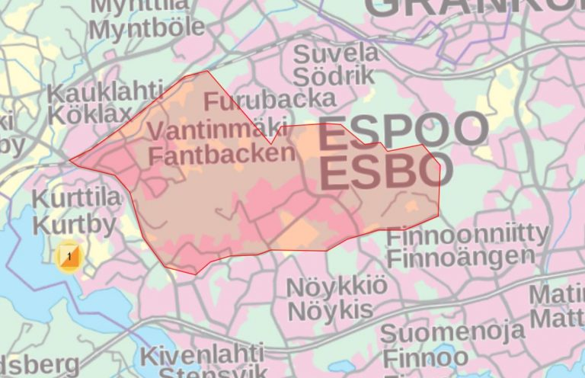

Terrain

The competition terrain for sprint consists of two types: urban business district and local outdoor area. Urban business district withholds different kind of business buildings and small parks in between them. Area is mainly asphalt. Local outdoor area is both fields and forest with lots of paths. Most of the paths are fast to bike. The heigh differences are very little in both areas.

The competition terrain for long-distance is local outdoor area. Local outdoor are is mainly forest with few fields. Contains lots of different paths, which vary in condition. The biggest outdoor paths are really fast whereas the smaller ones going up bare rock hills can be very tricky. The max heigh difference in area is around 30m.

Competition map

Scale: 1:10 000 (long), 1:7 500 (sprint), contour interval in both races is 5 m. Offset printed map with gray colour indicating bare cliff. Mapping made by Emil Laaksonen. The size of the map is A4.

Training possibilities

The organizers provide training map in part of local outdoor are that is outside competition area. The training maps costs 5€. You can contact event secretary for more information karipekka.seppanen@espoonsuunta.fi

First starts

First starts are local time 2pm on Saturday for sprint distance and 10am on Sunday for long distance

Food

The competition center will have canteen with coffee and snacks. The nearby area offers lots of restaurant opportunities for meals

Accommodation
Accommodation possibilities can be found with our partner Kisakallio
https://www.kisakallio.fi/

Weather

In April the weather in southern Finland can vary a lot. Typically, its something between +5-15 degrees Celsius.

Visa requirements

According to current regulations, citizens of some countries must obtain a visa in order to enter Finland.
Please check the following website for more information: www.formin.fi
Visas should be applied for at your closest Finnish embassy. Please note that conditions of entry may
change. All participants are advised to keep themselves updated on the situation by consulting their local
Finnish embassy.

Covid19

Ongoing Covid19 pandemic causes uncertainty. As organizers we will follow guidance from local authorities. This in mind some details concerning event details can change during the course of organizing. These changes will be updated in our website to keep all participants on track.
There are different requirements and restrictions from people coming abroad to Finland. We strongly advise participants to follow current regulations. More information on travelling and Covid19 can be found for example here https://thl.fi/en/web/infectious-diseases-and-vaccinations/what-s-new/coronavirus-covid-19-latest-updates/travel-and-the-coronavirus-pandemic

Final event instructions, start times and other information

There will be more information on the competition website closer to the date of the competition. Bulletin 2
will be published latest in the beginning of April 2021.

We are looking forward to meeting you in Espoo!

