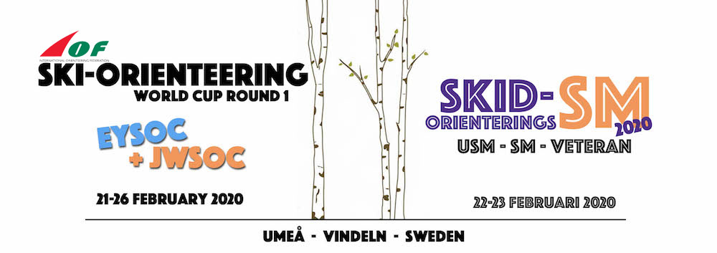
Each country must make orders for accommodations at the latest 5 February via mail: tjelvar@telia.com
We will send you a confirmation mail at the latest the 11 February, which each country have to confirm or make adjustments to at the latest 12 February.
After that date we can not guarantee that changes can be done. The fee for accomodation will be at the same invoice as for the entries, accreditation, transports and pre ordered food.
Questions and orders regarding accomodation should be sent to Event secretary Tjelvar Otterbjörk – tjelvar@telia.com
Marked on the map:
- Scandic Hotel Syd, accommodation and competition centre
- NY Hostel, accommodation
- First Camp, accommodation , self catering cabins
- Umeå Airport
- Umeå central railwaystation

Information about ACCOMMODATION
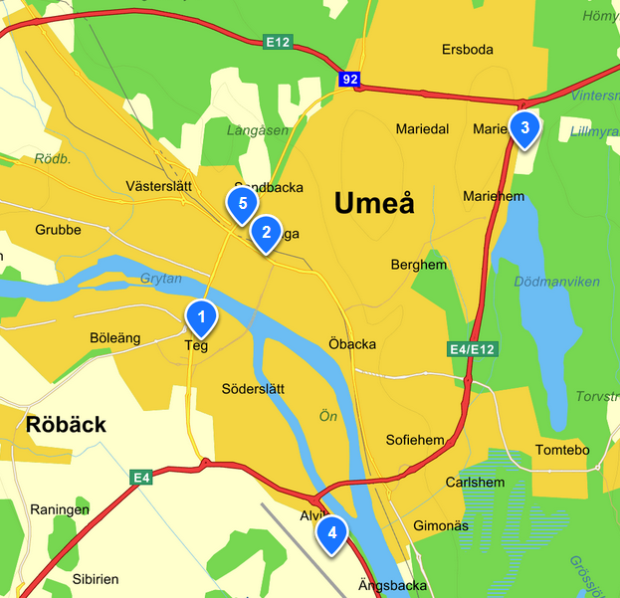
Accommodation alternatives 20-27 February 2020
- Scandic Hotel Syd (competition centre), including linens, breakfast and other facilities at the hotel (gym, small swimmingpool, free parking), Waxing can be done outside, under roof.
- 1A: Single room 60€/night
- 1B: Two-bed room 70 €/night
- 1C: Three-bed room 88 €/night
- 1D: Four-bed room 107 €/night
- NY Hostel - including linens and breakfast
- 2A: Two-bed room 70 €/night
- Self catering cabins at First Camp, Umeå - bring your own linens (or pay extra)
- 3A: 4-beds 70€/night
- 3B: 6 beds 102€/night

