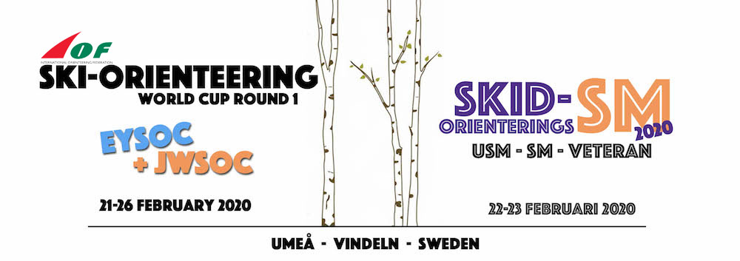
INFORMATION ABOUT TRANSPORTS
In order to make the transports between Umeå and Vindeln easier, cheaper and more environmentally sustainable we offer bus transports as follows:
Thursday 20 February:
We will arrange transports from Umeå Airport, or the railwaystations Umeå Ö or Umeå C, to your accommodation at Scandic Hotel Syd and First Camp. These transportations will be free of charge.
Friday 21 February:
We offer you free transport by bus from Scandic Hotel Syd and First Camp to the model event and back to the accommodation according to a special schedule during the day.
Saturday 22, Sunday 23, Tuesday 25 and Wednesday 26 February.
We offer bus tickets for 30€/person that include transport all four days of races between the accommodations in Umeå, to the event centre in Vindeln, and back to Umeå again. The fee for the bus tickets is highly reduced, thanks to sponsors - Visit Umeå and Umeå Buss.
The schedule for the bus transport will be customized so that the first starting competitor in each bus will arrive to the event centre in Vindeln at least 90 minutes before start on Saturday and Sunday, and at least 105 minutes before start on Tuesday and Wednesday.
Transports for waxing staff
We will not offer any special organized transports for waxing staff. We recommend the national teams to cooperate regarding rental vehicles for waxing staff. There are several car rental companies in Umeå.
How to order transports
Each country must make orders for transports via a special form, that should be sent at the latest 5th of February via mail to tjelvar@telia.com
We will send you a confirmation mail at the latest the 11th of February, which each country have to confirm, or make adjustments to, at the latest 12th of February.
After that date we can not guarantee that changes can be done. The fee for transports will be at the same invoice as for the entries, accreditation, accommodation and food. Questions and orders regarding transports should be sent to Event secretary Tjelvar Otterbjörk – tjelvar@telia.com

