ORIENTEERING WORLD CUP
FINAL 2019
(GUANGDONG, CHINA)

2019.10.24-30
Bulletin – Open Class

Open Class
The Open Class will be held on the same dates as the World Cup - an event with participation of the best orienteering athletes all around the world. When you take part in the open class event, you can not only enjoy the competition, but also cheer for the elite runners as an orienteering fan.

Date:
Saturday, October 26, Middle Distance Sunday, October 27, Sprint #1
Tuesday, October 29, Sprint #2
Note: Middle Distance is exclusively for M21E and W21E.

Entry Method:
Please fill in the entry form and send it to htochina@yahoo.com. Deadline: September 30, 2019
No entry will be accepted after the deadline.

Entry Fee:
Middle Distance: €15/person/race Sprint #1: €15/person/race
Sprint #2: €15/person/race
Package Price for all 3 races: €40/person

Number of Participants:
- The number of participants for open class has the limitation of 200 peo- ple. First come, first serve.
- The number of participants for M21E/W21E Middle Distance has the limitation of 25 runners. (In accordance with the IOF ranking, 25 M21E/W21E athletes will be selected from all foreign athletes registered for open class. Those who made entries for M/W21E but not selected will be put into M/W21A.)

Classes:
M8: born after January 1, 2011
W8: born after January 1, 2011
M10: born after January 1, 2009
W10: born after January 1, 2009
M12: born after January 1, 2007
W12: born after January 1, 2007
M14: born after January 1, 2005
W14: born after January 1, 2005
M16: born after January 1, 2003
W16: born after January 1, 2003
M18: born after January 1, 2001
W18: born after January 1, 2001 M21A: no age restrictions
W21A: no age restrictions
M21E: elite class, no age restrictions W21E: elite class, no age restrictions M35: born before December 31, 1984
W35: born before December 31, 1984 M40: born before December31, 1979 W40: born before December31, 1979 M45: born before December31, 1974 W45: born before December31, 1974 M50: born before December31, 1969 W50: born before December31, 1969

Note: Groups may be diveded numerically into Group 1 & Group 2 when many participants enter in the same class, e.g.: M21A-1 & M21A-2.

Payment for Open Class:
Beneficiary Account Name: Foshan Last Minute International Tourist Co.，Ltd
Bank Account: 2013 0199 0920 0085 424
Bank: INDUSTRIAL & COMMERCIAL BANK OF CHINA GUANGDONG NAN- HAI SUB-BRANCH
Swift Code: ICBKCNBJGDG
Bank Address: 73 NORTH NANHAI AVE，NANHAI FOSHAN GUANGDONG CHINA

Liaison staffs for payment confirmation:

English Speaking - Ms. Guan Ruiying
Mobil: +86 13827776663; Email: 2484969867@qq.com.
Chinese Speaking - Ms. Wu Huiyi
Mobil: +86 13923136680; Email: 529570353@qq.com. Note: Bank charges will be fully paid by payment sender.
Important: The entry submission is confirmed after the payment is re- ceived. Unless entry fee is paid, the entry is not valid. The payment for entries shall reach the Organizer’s bank account no later than October 1, 2019. Remittance information including team name and number of par- ticipants should be sent while the payment is made.

Start Time:
Open Class event will start in accordance with the start order choreo- graphed by the Organizer after the start of the World Cup athletes. World Cup Middle Distance on Saturday will start at ca 1 pm while World Cup Sprint Relay on Sunday will start at ca 2:45 pm and World Cup Sprint on Tuesday will start at ca 2 pm.

Punching System:
The punching system used is SPORTident.

Open Class Races:
Middle distance
Date: Saturday, October 26
Terrain: The terrain is on a mountain plateau with generally moderate slopes. Mostly na- tive forest, with some areas of villages and developed parklands. There is a wide varia- tion in vegetation but most forest areas have good runnability. There is a dense path net- work.
Map: scale 1:10000, contour interval 5 m, ISOM 2017

Sprint #1
Date: Sunday, October 27
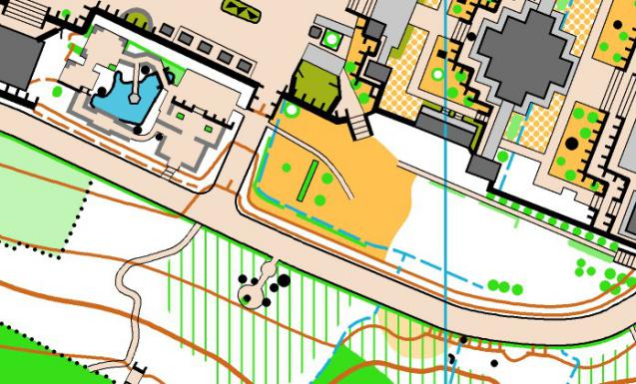
Terrain: Located here is an open-air film studio complex with numerous replica townscapes and temples, combining the landscape of a city park and suburban park with strong cultural atmosphere. There is both planted and natural vegetation. Very good runnability.
Map: scale 1:4000, contour interval 2 m, ISSOM 2007

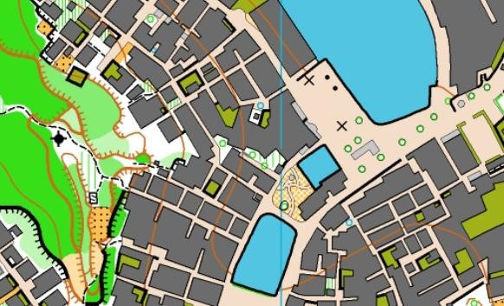

Sprint #2
Date: Tuesday, October 29
Terrain: Ancient villages with both tradi- tional and modern architectural styles, with areas of farmland and ponds between the built-up areas. The alleys are quite narrow, mainly made of bricks. The terrain is gener- ally fairly flat.
Map: scale 1:4000, contour interval 2.5 m, ISSOM 2007 Course Planning

