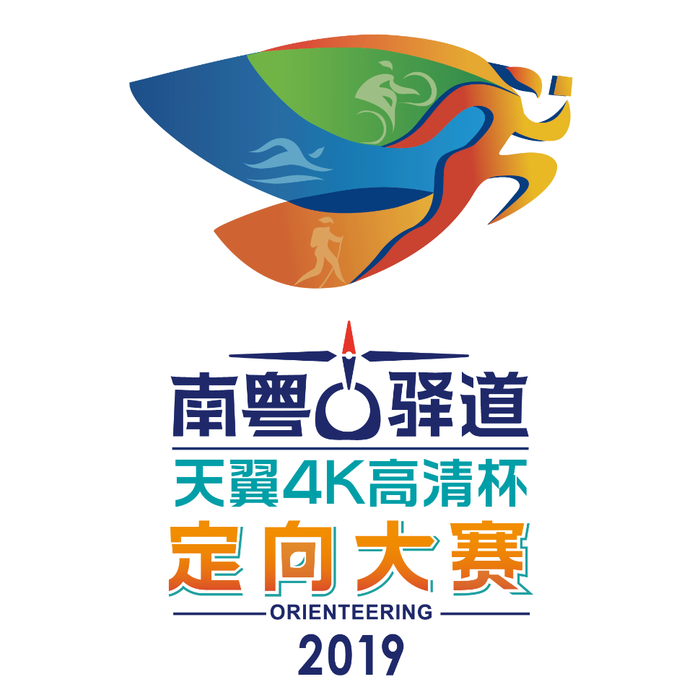

2019 Guangdong Historical Road Orienteering Championship 'Surfing 4K IPTV' Cup

BULLETIN 1

- PROGRAMME
Race S/N | Date | Location
Station 1  Meizhou | 20-21/4/2019 | Bachi Town, Pingyuan County, Meizhou City
Station 2  Zhaoqing | 1-2/6/2019 | Jinlinshuixiang, Guanxu Town,  Deiqing County, Zhaoqing City
Station 3  Heyuan | 24-25/8/2019 | Yihe Town, Dongyuan County, Heyuan City  (Sujiawei, Xiayu Village)
Station 4  Qingyuan | 21-22/9/2019 | Shuikou Village, Yangcheng Town, Yangshan County, Qingyuan City
Station 5  Foshan  (World Cup） | 26-29/10/2019 | Nanhai District, Foshan City  (Xiqiao Town, Shishan Town)
Station 6  Yangchun | 15-16/11/2019 | Gao Village, Chunwan Town, Yangchun, Yangjiang City
Station 7  Maoming | 16-17/11/2019 | Bafang Village, Zhenlong Town, Xinyi, Maoming City
Station 8  Shaoguan | 29-30/11/2019 | Daqiao Village, Daqiao Town, Ruyuan County, Shaoguan City
Final  Yunfu | 14-15/12/2019 | Shuidong Village, Yaogu Town, Yuncheng District, Yunfu City

1.1 Schedule
Date | Time | Activity
Day 1  (Check the schedule of each event) | 10:00-14:00 | Runners arrive and get materials for the event.
 | 14:00-15:00 | Take the shuttle bus to the competition terrain.
 | 15:00-17:00 | Sprint or Middle Distance  (Youth, Professional and Adult)
 | 17:00-17:30 | Awarding Ceremony
 | 18:30-20:00 | Runners’ meeting and dinner.
Day 2  (Check the schedule of each event) | 07:00-08:00 | Take the shuttle bus to the competition terrain.
 | 08:30-09:00 | Warm-up
 | 09:00-09:30 | Opening Ceremony
 | 09:30-12:00 | Team event  (Youth, Professional and Adult) )  Sprint or Score Orienteering  (Experience)  Radio direction finding event
 | 12:00-12:30 | Awarding Ceremony
 | 13:00 | Departure

2. LOCATION & VISIT
2.1 ARRIVAL
Foreign participants are suggested arriving at Guangzhou Baiyun International Airport. Shuttle buses will be arranged to/from the Airport and the official hotel of event by the Organizer. The transportation bus needs to be made an appointment in advance, and the transportation fee must be paid at the time of registration. The amount is to be determined.

2.2 EVENT CENTRE
Free shuttle buses will be arranged to/from the official hotel and the event center.

2.3VISA
In accordance with current state regulations, some citizens of other countries must apply for a visa to enter China. Please confirm the necessity for the visa application.
Invitation letter from the Organizer will be issued upon request. Please contact our staff via email htochina@yahoo.com for further inquiry.

3. CLASSES & AWARDS
3.1 CLASSES
Youth
M8（born after 1st January, 2011)
W8（born after 1st January, 2011)
M10（born after 1st January, 2009)
W10（born after 1st January, 2009)
M12（born after 1st January, 2007)
W12（born after 1st January, 2007)
M14（born after 1st January, 2005)
W14（born after 1st January, 2005)
M16（born after 1st January, 2003)
W16（born after 1st January, 2003)

Professional
M18 (born after 1st January, 2001)
W18 (born after 1st January, 2001)
M21A (regardless of age)
W21A (regardless of age)
M21E (elite, regardless of age)
W21E (elite, regardless of age)
M35 (born before 31th December, 1984)
W35 (born before 31th December, 1984)

Adult
M40 (born before 31th December, 1979)
W40 (born before 31th December, 1979)
M45 (born before 31th December, 1974)
W45 (born before 31th December, 1974)
M50 (born before 31th December, 1969)
W50 (born before 31th December, 1969)

Experience
Family(parents with children, regardless of age and gender）
Student (studied in local school, regardless of age and gender)
Villager (lived in local areas, regardless of age and gender)
Public (freely combined by the public, regardless of age and gender)

Radio direction finding

(only set selectively in some races. For more details, please seek from the competition rules.)
M12 (born after 1st January 2007)
W12 (born after 1st January 2007)
M15 (born after 1st January 2004)
W15 (born after 1st January 2004)
Runners of M/W21E shall comply with the following requirements:
Participating in and completing international competitions organized by the International Orienteering Federation of any classes except experience.

3.2 AWARDS
(1) For M/W21E, M/W21A and villager classes, trophies, medals and certificates will be rewarded to the first 3 places while medals and certificates will be rewarded to the 4th to 8th places. For else classes, certificates will be rewarded to participants in the first 3 places in each event.
(2) For Radio direction finding individual Class, trophies, medals and certificates will be rewarded to the first 3 places while medals and certificates will be rewarded to the 4th to 8th places. For team events, certificates will be rewarded to the first 6 places.
(3)All participants will be rewarded the complementary medals and certificates upon the completion of the event within the effective time.
(4) All runners in youth, professional and adult classes will get scores in each station and are awarded by the annually.
(5) When the number of runners in any groups is less than 3, there will be only completion certificates for them but no awards. However all runners of youth, professional and adult will still get the scores.

4. COMPETITION RULES
The competitions will be organized in accordance with the IOF Competition Rules and Competition by-law from China Orienteering Association.

5. ENTRY
5.1 There is no entry fee for all participants. A T-shirt will be offered to
each participant for free when he/she registers successfully.
5.2 Entry Deadline：Two weeks before each event.

5.3Entry Method：
Foreign runners please submit the entry form to htochina@yahoo.com by the above-mentioned deadline.

6. ACCOMMODATION & MEALS
During the Competition, accommodation and three meals per day will be offered to all foreign participants by the Organizer.
Remarks: Free accommodation and meals will be offered to 20 foreign runners who have the earliest registration. (Except for stop 5)

7. CLIMATE
Guangdong is situated in the subtropical coastal zone with a marine subtropical monsoon climate, with an average temperature of 19-24℃. The average temperature in August is about 30-32℃ and in December it is about 10-16℃.

For weather forecast please refer to the following link:
http://gd.weather.com.cn/

8. REVIEW OF EVENTS
2017 Guangdong Historical Road Orienteering and WRE:
https://v.youku.com/v_show/id_XMzQ1MTIwOTIzNg==.html?spm=a2h0k.11417342.soresults.dtitle

9. Contact
Email ：htochina@yahoo.com
PS ：ENTRY FORM SAMPLE
The following entry form is used for foreign runners only.
