Embargoed Areas for EOC 2020
Event | European Orienteering Championships and World Cup Final 2020  (EOC & WCUP 2020) in Rakvere, Estonia
Embargo valid from:  (date) | 2018-04-27
Change tracking: | 2018-04-27: Version 1 published  2019-09-05: Version 2 published (embargoed area decreased on NE side: area in north of road no 115 (and map of Mõedaku) is no longer an embargoed area)
Overview map:  (country overview) | 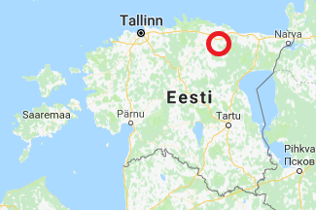
Detailed Embargoed areas info:  (link to Google maps) | https://www.google.com/maps/d/viewer?mid=14YC7L2d-pg0RM3yy04Be00P6AbZJqZXZ&ll=59.32046603261861%2C26.498381351119974&z=11
Other areas info
Event contact person for embargoed areas: | Name: | Email/Telephone no:
 | Jaan Tarmak | jaan@sk100.ee
Event contact for training areas | Mait Tõnisson | trainings@eoc2020.ee

