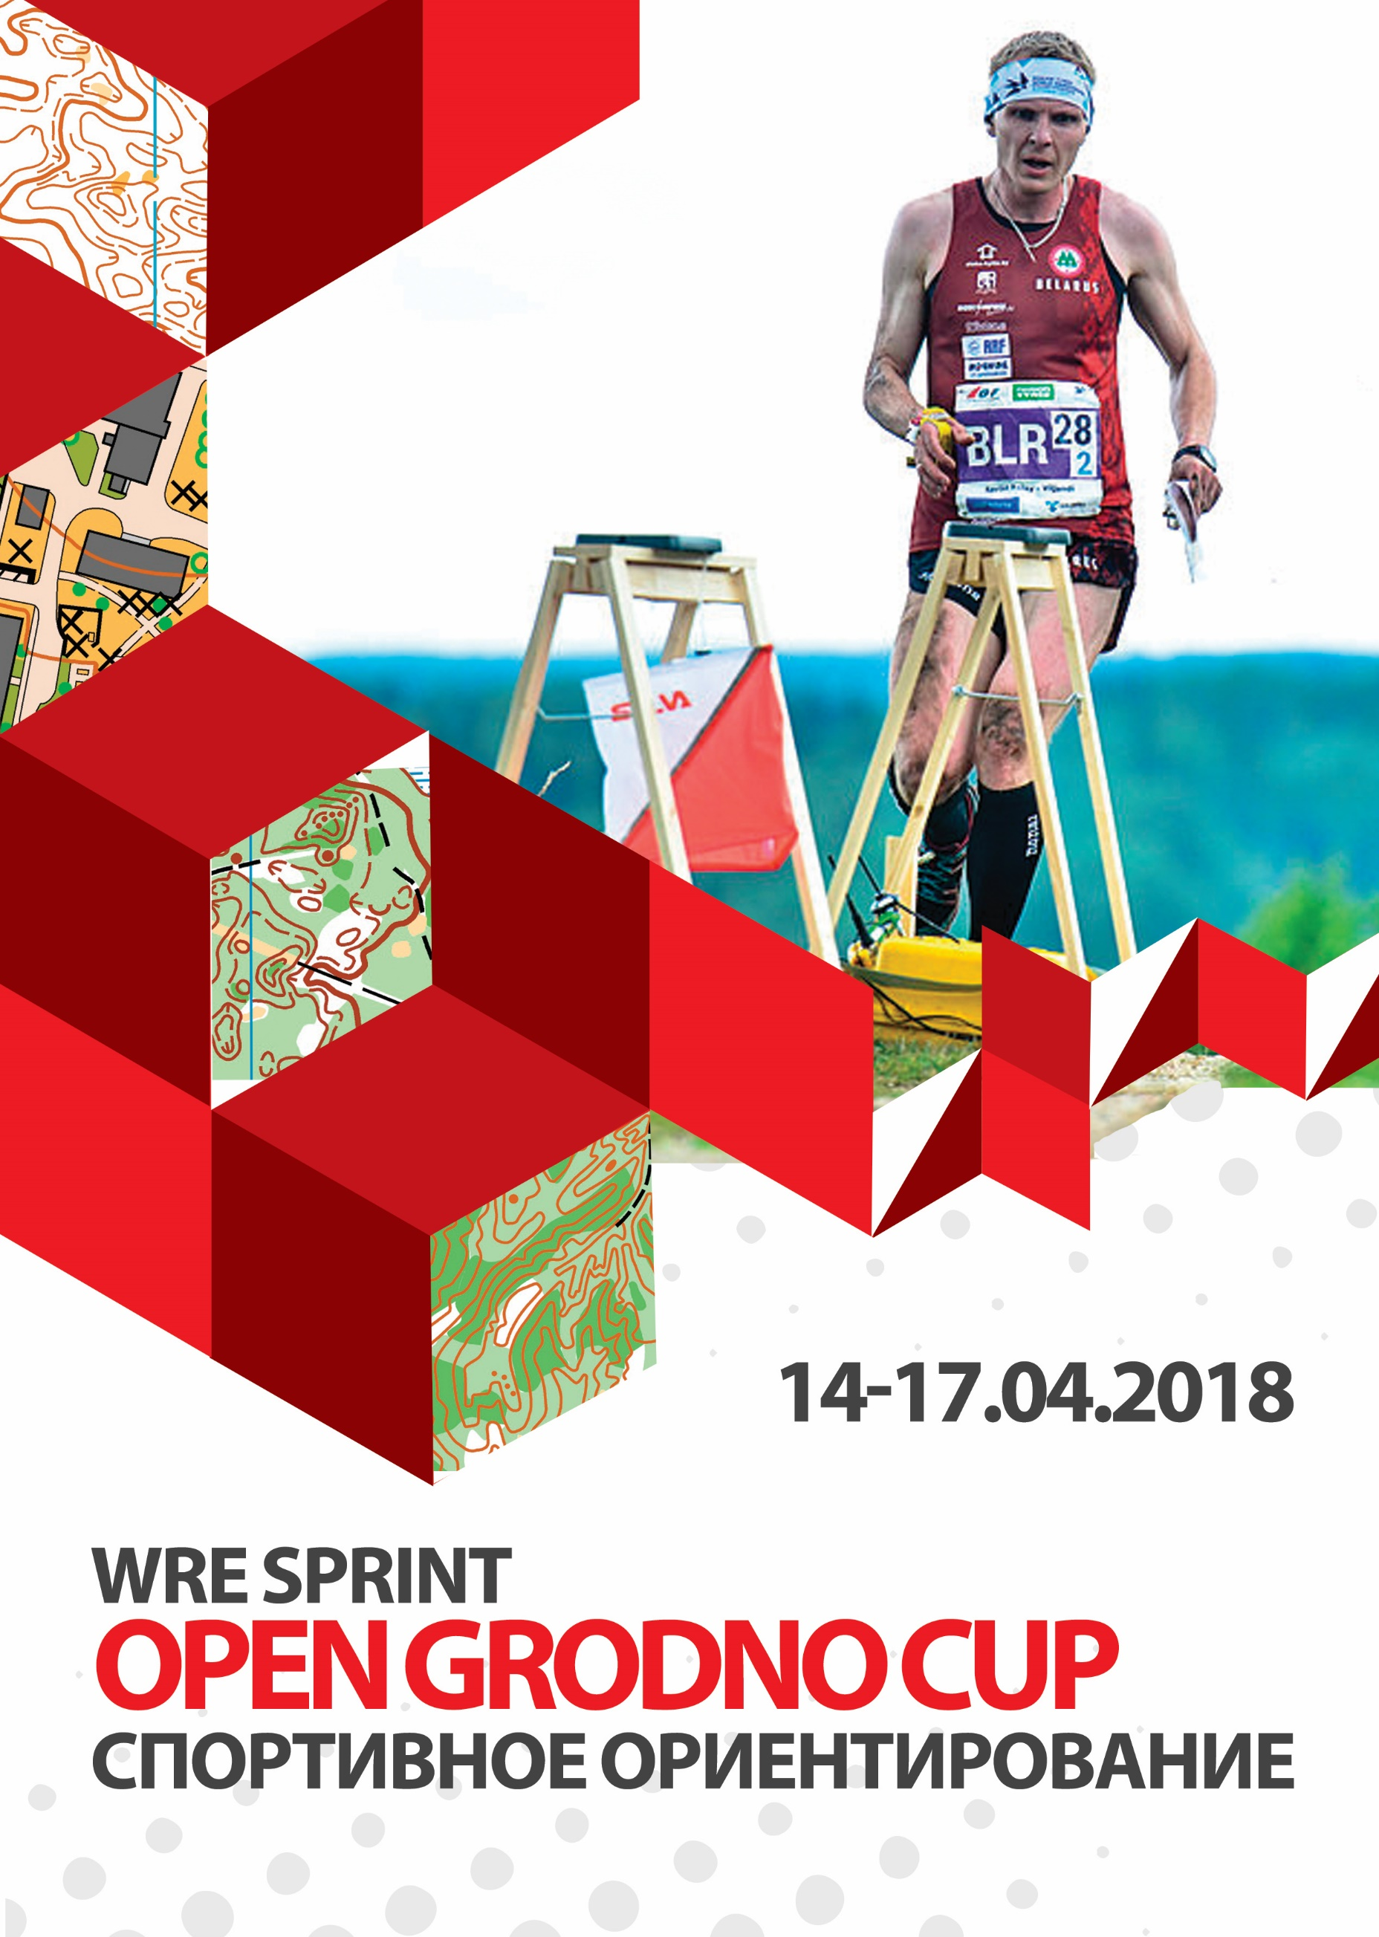
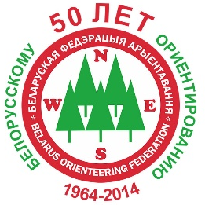

BULLETIN 2

«OPEN GRODNO CUP – 2018»

World ranking event (sprint)

of the International Orienteering Federation

II-IV Stages of the Belarus Orienteering Federation Cup

IV Stage of the Belarus Orienteering Federation Cup on

sprint distance

V-VII Stages of the Belarus Orienteering Federation Veterans Cup

III-IV stages of the junior ranking Belarus Orienteering Federation

III-IV stages of the youth ranking Belarus Orienteering Federation

14-17 April, 2018

Ministry of sport and tourism of the Republic of Belarus, the Belarus Orienteering Federation, Grodno region Orienteering Federation, Grodno City Executive Committee, the Yanka Kupala State University of Grodno and the “Kronan” Sports Orienteering Club invite you to take part in the start of the International Orienteering Federation World Ranking (IOF WRE) within the traditional individual and team “Open Grodno Cup – 2018” competition in the city of Grodno, Republic of Belarus. The competition has been held since 1977.

COMPETITION VENUE
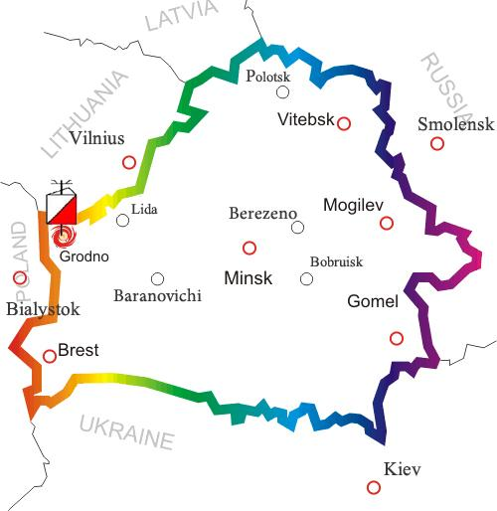
The city of Grodno is located in the West of Belarus. 265 km West of Minsk and 280 km North of Brest, 30 km from the border with the Republic of Lithuania and 20 km from the border with the Republic of Poland.

COMPETITION CENTER / CONTACTS

Competition center:
Sports Orienteering Club “Kronan”, BLK, 3 Grodno, Republic of Belarus.

Postal address for correspondence:
230027, Republic of Belarus, Grodno, Olga Solomova str., 118-85.

Organizational matters (Russian, Polisj): Edvard Arodz +375 29 5889911, ed_91161@mail.ru
Organizational matters (English): Dmitry Krapivko +375 29 5664479, freid-7@tut.by

Competition website: kronan.by

Chief Referee: Arodz E.
Chief Secretary: Orochko E.
Deputy the main referee on distances: Krapivko D.
Controller BFO: Davidovich D.
Inspectors: Schwantz A., Arodz E., Krapivko D.

SCHEDULE

«OPEN GRODNO CUP  – 2018» | 14.04.2018  (Saturday) | Day 1  12.00-13.30 Registration at competition arena.  14.00 Start. Middle distance.
 | 15.04.2018  (Sunday) | Day 2  9.00-11.30 Registration at competition arena.  11.30-11.45 Opening ceremony for the Grodno Cup-2018 competition.  12.00 Start. Sprint distance. IOF WRE.  14.30 Flower ceremony for the sprint distance IOF WRE. Groups M21E and W21E.
 | 16.04.2018  (Monday) | Day 3  - 11.00 Start. Classic distance.
 | 17.04.2018  (Tuesday) | Day 4  - 10.00 Start. Middle distance.  - 14.00 Prize-giving ceremony of the “Open Grodno Cup-2018”.

GROUPS

The competition is held in the following groups:
M/W: 10 (marking), 12, 14, 16, 18, 21E, 21A, 35, 45, 50, 55, 60, 65, 70.
Open 1 (technically complicated and short-length distance),
Open 2 (technically simple and short-length distance).

On the 2nd day of the competition the IOF WRE start will take place for M/W 21E groups.
In case of a small number of participants in a group (less than 5), the organizers reserve the right to unite groups. Team lists are not limited.

MAPS

Middle distance  14.04.2018  “Prigodichi-2”  (new map) | Sprinter distance  15.04.2018  “The zoo”  (new map)
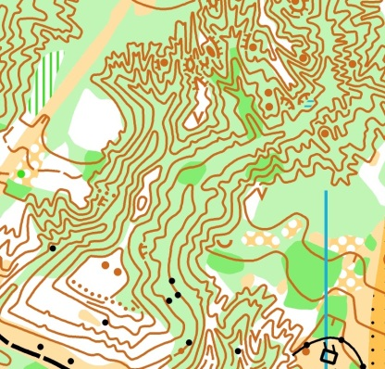 | 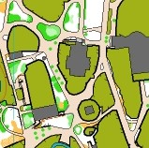
Author: A. Efimenko  Scale 1:7500  Contours 5 m | Author: D. Krapivko  Scale 1:4000  Contours 2 m

Classic distance  16.04.2018  “Tartak”  Prepared  2016-2017 | Middle distance  17.04.2018  “Augustov channel-2»  Prepared  2016-2017
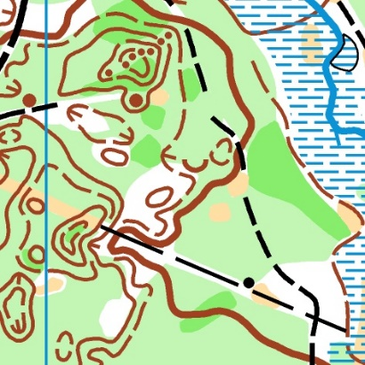
Author: S. Usenko  Scale 1:10 000  Contours 2,5 m | Authors: S. Usenko  S. Vorobei  Scale 1:10 000  Contours 2,5 m

APPLICATION / FINANCING

Expenses associated with the organization and arrangement of competitions shall be covered by the organizers. Expenses for the teams’ participation in the competition (travel, accommodation, food, entry fee) are to be covered by the sending organizations.
To apply for the competition you need to fill out the application form which is available at the website kronan.by or at the direct link.

When participating in the IOF WRE start, all athletes of the M/W 21E groups must create an account in the IOF Eventor system and also apply for participation in the ranking start via the IOF Eventor system.

When receiving the start package, please present a medical certificate of your state of health, certified by a doctor. Mature participants may present a signed acknowledgement of personal responsibility over your health and safety (the form will be available at the competition website and when receiving the start package).
Entry fee amounts:
 | Number of starts | МW10-18  МW 65,70 | МW 21А,  35-60 | MW21E | Open 1  Open2
Fee when applying before 09.04.2018  (both dates inclusive) | 1 | 9 | 12 | 15 | 6
 | 2 | 16 | 22 | 28 | 12
 | 3 | 21 | 30 | 39 | 18
 | 4 | 24 | 36 | 48 | 24
Fee when applying  10-12.04.2018 | + 50%
Fee when applying  13-14.04.2018  If vacancies are available | + 100%
SI-card rental | х | 2 | 2 | 2 | 2
All sums are provided in Belarusian rubles – BYR.

A discount system is in place at the competition:
• minus 100% of the entry fee:
-honorary BOF members;
-personally for Vladimir Kondratyev, Maksim Borysenko, Anastasia Kevra, Mikhail Synkov, Dmitry Vashkevich, Daniil Yanshin, Pavel Krasko, Andrei Murashko, Vladimir Vasilenok, Anatoliy Bukovets, Sofia Karelina, Olga Tomasheva, Angelina Katkova, Valeria Gavrilova, Aleksandra Vankevich, Anastasia Atamanovich, Bozhena Levchik, Ludmila Pirogova, Lidia Makarevich.

2. minus 50% of the entry fee:
Orienteering Club “Kronan” members.

3. minus 10% of the entry fee:
- children’s teams, 15 persons and up;
- families, three persons and up.

Please state your discount in the application form.

The entry fee amount will be stated opposite each participant’s surname in the general list.
The entry fee and the chip rental amount need to be transferred to the business account before 11.04.2018, in this case the sum of the fee is defined based on the application date. Starting on 12.04.2018, the amount of the application fee will be defined based on the payment date thereof.
No punitive sanctions will be applied regarding the application date for groups Open1, Open2.
Cash payment during the competition is allowed only for foreign participants. The sum of payment is determined based on the application date.
The entry fee will not be returned to participants who fail to arrive.

Payment details:
RECIPIENT: Grodno region Orienteering Federation
УНП 590374378
GOU OAO "ASB Belarusbank", Branch No. 400, 230023 Grodno, street Ozheshko, 4
BIC AKBBBY21400
р/с BY35 AKBB 3015 0000 4602 7400 0000
Purpose of payment: financing of competitions.
Payer: specify payer's name or team name (in case of group payment).

PRELIMINARY DISTANCE PARAMETERS

Группа | 14.04 | 15.04 | 16.04 | 17.04
M10 | 1,3 | 1,0 | 2,5 | 2,1
M12 | 1,4 | 1,7 | 2,9 | 2,7
M14 | 2,0 | 2,2 | 3,9 | 3,7
M16 | 2,1 | 2,2 | 4,9 | 4,7
M18 | 3,0 | 3,7 | 7,0 | 6,3
M21E | 4,4 | 4,0 | 10,2 | 6,8
M21А | 3,5 | 3,2 | 7,8 | 6,3
M35 | 4,1 | 3,7 | 8,8 | 5,8
M45 | 3,6 | 3,7 | 7,2 | 5,7
M50 | 3,5 | 2,5 | 7,2 | 4,2
M55 | 3,0 | 2,5 | 6,7 | 4,5
M60 | 2,9 | 2,5 | 6,7 | 4,7
M65 | 2,8 | 2,5 | 6,3 | 3,8
M70 | 2,1 | 2,0 | 6,0 | 3,2
W10 | 1,3 | 1,0 | 2,5 | 2,1
W12 | 1,4 | 1,6 | 2,9 | 2,7
W14 | 1,4 | 2.2 | 3,9 | 3,2
W16 | 2,0 | 2,2 | 4,9 | 3,7
W18 | 2,1 | 2,2 | 6,3 | 4,7
W21E | 4,1 | 3,7 | 8,8 | 5,8
W21А | 2,1 | 2,5 | 6,8 | 4,3
W35 | 3,0 | 2,5 | 7,7 | 5,7
W45 | 2,1 | 2,5 | 6,3 | 4,5
W50 | 2,0 | 2,5 | 6,2 | 4,7
W55 | 2,0 | 2,5 | 6,2 | 3,8
W60 | 1,8 | 2,5 | 5,7 | 3,6
W65 | 1,8 | 1,8 | 5,7 | 3,6
W70 | 1,7 | 1,6 | 5,3 | 3,0
Open1 | 3,5 | 3,2 | 7,8 | 6,3
Open2 | 2,0 | 2,5 | 6,2 | 4,3

PUNCHIG SYSTEM

The competition will employ electronic SPORTident system. It is also allowed to take part with personal SI-cards of any series.
You can also rent SI-cards from the organizers.
The fee in case of rental from the organizers is 2 Rubles for all days of the competition.

GPS-TRACKING

During the competition in groups M/W 21E, GPS-trackers will be used. These athletes’ progress can be monitored in real time on location and online at the link available on the competition website.

ACCOMODATIONS

We can book the following for you (if you apply before 09.04.18):
- The “Fisherman’s house” leisure base - (on the map) (site)
- “Sport” hotel – 15 places total -22 BYN/day (on the map) (site)
- “Kupalinka” leisure base - 200 places total - 12,28 BYN/day (on the map) (site)
- Trade college dormitory (block type, 2- and 4-person rooms), 15 places total - 15 BYN/day
- Pyshki” tourist complex - 17 places total -31.93 BYN/day.
- “Sarmatia” hostel 10 BYN/day (site)
- «Old Bridge» hostel, 53 places total.
14-person 10 BYN/day.
10-person 11.20 BYN/day.
6-person 13,40 BYN/day.
4-person 14,80 BYN/day.
3-person -15,20 BYN/day.

- Tent camp №1 – (on the map) – Guarded terrain, drinking water, shower, toilet, electricity, firewood, outdoor grills and hotplates are allowed. Price - 2 BYN per person for the whole time of accommodation.
- Tent camp №2 – (on the map) – near the start place 16-17.04.2018.
accommodation free of charge.

You can find accommodation independently:
- Grodno hotels: belarushotels.by, hotel.by, booking.com.

MEALS

Meal expenses are to be covered by the competition participants themselves.
3 daily meals at a cafeteria can be arranged
The “Kupalinka” leisure base – per advance request before 09.04.2018.
Addresses: cafes, cafeterias, stores.
The “O-Café” will be open at the competition arenas.

TRANSPORT

The athletes shall use personal and public transport. Also, per advance notice, special organizer transport will be available:
14.04.18 – to the middle distance arena and back.
16.04.16 – to the classis distance arena and back.
17.04.18 – to the middle distance arena and back
Price of travel in both directions – 2 BYN/day.

VISAS

All foreign participants can come to the competition without applying for a visa.
Additional information is available at http://grodnovisafree.by/en/, or via kronan@tut.by
Also all foreign participants can receive a free visa based on an invitation of the competition organizers, provided they apply for the visa no later than 1 month before the start of the competition.
Send requests to: kronan@tut.by

http://www.belarus.by/en/travel/travel-visas
http://belarustourism.by/

SUMMING UP

In the individual classification the places will be distributed based on the sum of points received in the 3 best starts in the 4 days of the “Open Grodno Cup-2018” competition.

The participant’s points are calculated based on the following formula:
1000 + 200 х (average time in the group – participant’s time) / standard deviation
Average time and standard deviation are calculated among all group participants.

The total team result is determined by the largest point sum of 10 team members in any group based on the results of the individual classification. A coefficient of 1.3 is applied to groups M/W21Е.
In case the points are equal, preference is given to the team that has the most first places
(then second places, third etc.).

