**World Masters Orienteering Championships 2018**

**Copenhagen, Denmark**

**Bulletin 1**

**Organisers**

Danish Orienteering Federation, Farum OK, OK Øst Birkerød, Søllerød OK and Tisvilde Hegn OK



**Contact information**

Event Director: Ole Husen

Address: WMOC 2018

Enghave 28, 2960 Rungsted Kyst, Denmark

Telephone: +45 4015 4416

Website: [www.wmoc2018.dk](http://www.wmoc2018.dk)

Email: [info@wmoc2018.dk](mailto:info@wmoc2018.dk)

**Controllers**

IOF Senior Event Adviser: Tony Thornley (GBR)

IOF SEA Assistant: Steve McKinley (GBR)

National Controller: Ulla Place Petersen.

**Venue**

[**Denmark**](http://denmark.dk/)   
Situated in southern Scandinavia, the Kingdom of Denmark covers an area of 42.916 square kilometres and with a population of 5,6 million, the population density is 130 per square kilometre. You will discover Denmark to be a well-organised, friendly and safe country to visit. Denmarkhas a temperateclimate. Average daily temperature in July is 15,6 oC. more info: [www.dmi.dk](http://www.dmi.dk).

**[Copenhagen](http://www.visitcopenhagen.com/copenhagen-tourist)**  
Situated at Øresund, The Danish capital has a population of 1,2 million inhabitants. Among other things, Copenhagen is famous for Tivoli Gardens, The Little Mermaid, Christiansborg Palace, the Queens residence Amalienborg and Nyhavn. Copenhagen furthermore encourages green living.

**North Zealand**

Named Denmark’s Royal Retreat due to the many Royal castles in the region. The beautiful north coast of Zealand is also called the Danish Riviera.

The Sprint competitions take place in Hørsholm north of Copenhagen and in central Copenhagen – the capital of Denmark. The Long and Middle Distance competitions are held in North Zealand – with the Qualification race and Middle Final in Tisvilde Hegn and the Long Final in Grib Skov.

**Event Centre**

The Event Centre will be in Farum Arena, which is centrally located in North Zealand. It is easily accessible by car or public transport.  
Farum Arena offers O-camp and floor accommodation in class rooms. All information about the event will be given here. O-related workshops are planned to take place during the event week.  
Farum Arena has hosted WTA Tennis tournaments and handball Champions’ League matches. The nearby Farum Park has hosted football Champions League. There will also be accommodation possibilities here.

Distances from the Event Centre to:  
• O-camp: 150 metres 1/8

• Sprint Model Event: 0 metres  
• Classroom accommodation in school rooms: 50 metres  
• Farum Bytorv shopping centre: 500 metres  
• Farum S-train station: 1200 metres  
• Furesøbad lake swimming site: 2000 metres  
• Nørreskoven forest training area: 2000 metres

**Programme**

|  |  |  |
| --- | --- | --- |
| Thursday | 5th of July | Event Centre opens |
| Friday | 6th of July | Model event Sprint – Opening ceremony |
| Saturday | 7th of July | Sprint Qualification |
| Sunday | 8th of July | Sprint Final – Prize giving ceremony |
| Monday | 9th of July | Model event Forest Qualification and Middle Final – Rest day |
| Tuesday | 10th of July | Forest Qualification |
| Wednesday | 11th of July | Middle Final – Prize giving ceremony – Banquet |
| Thursday | 12th of July | Model event Long Final – Rest day |
| Friday | 13th of July | Long Final – Prize giving ceremony – closing ceremony |

**Competitions**   
The WMOC Sprint distance competition consists of one Qualification race and a Final race. The WMOC Forest distances competitions consists of one Qualification race, a Middle Final race and a Long Final race. Qualifiers for each Final will be determined in accordance with IOF Competition Rules. Details will be published in Bulletin 2 and on our website when they are confirmed by the IOF.

|  |  |  |  |  |  |  |  |  |  |  |
| --- | --- | --- | --- | --- | --- | --- | --- | --- | --- | --- |
| **Class** | **SQ+SF** | **FQ** | **MF** | **LF** | **Class** | **SQ+SF** | **FQ** | **MF** | **LF** | **Born** |
| M35 | 12-15 | 50 | 30-35 | 70 | W35 | 12-15 | 40 | 30-35 | 55 | 1983 |
| M40 | 12-15 | 50 | 30-35 | 65 | W40 | 12-15 | 40 | 30-35 | 50 | 1978 |
| M45 | 12-15 | 45 | 25-30 | 60 | W45 | 12-15 | 35 | 25-30 | 45 | 1973 |
| M50 | 12-15 | 45 | 25-30 | 55 | W50 | 12-15 | 35 | 25-30 | 45 | 1968 |
| M55 | 12-15 | 40 | 25-30 | 50 | W55 | 12-15 | 35 | 25-30 | 45 | 1963 |
| M60 | 12-15 | 40 | 25-30 | 50 | W60 | 12-15 | 35 | 25-30 | 45 | 1958 |
| M65 | 12-15 | 40 | 25-30 | 50 | W65 | 12-15 | 35 | 25-30 | 45 | 1953 |
| M70 | 12-15 | 40 | 25-30 | 50 | W70 | 12-15 | 35 | 25-30 | 45 | 1948 |
| M75 | 12-15 | 40 | 25-30 | 50 | W75 | 12-15 | 35 | 25-30 | 45 | 1943 |
| M80 | 12-15 | 40 | 25-30 | 50 | W80 | 12-15 | 35 | 25-30 | 45 | 1938 |
| M85 | 12-15 | 40 | 25-30 | 50 | W85 | 12-15 | 35 | 25-30 | 45 | 1933 |
| M90 | 12-15 | 40 | 25-30 | 50 | W90 | 12-15 | 35 | 25-30 | 45 | 1928 |
| M95 | 12-15 | 40 | 25-30 | 50 | W95 | 12-15 | 35 | 25-30 | 45 | 1923 |
| M100 | 12-15 | 40 | 25-30 | 50 | W100 | 12-15 | 35 | 25-30 | 45 | 1918 |

**Legend**  
SQ = Sprint Qualification – winning time in minutes  
SF = Sprint Final – winning time in minutes  
FQ = Forest Qualification – winning time in minutes  
MF = Middle Final - winning time in minutes  
LF = Long Final – winning time in minutes  
Born: In order to participate, the athlete must be born in the year indicated or earlier.

**Medals:** Will be awarded to the first three finishers in each class. (A-finals) 2/8

**All in one place – short distances**

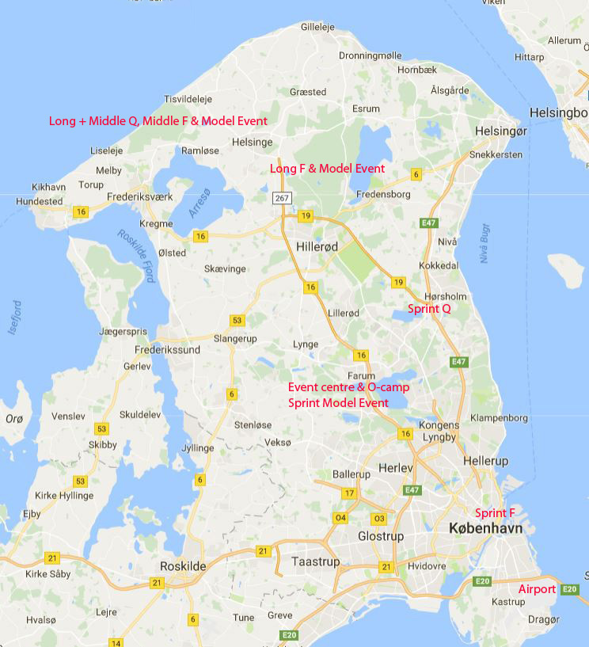

10 km

Distances between the Event Centre and the different locations shown on map in red are less than 35 kilometres.

3/8

**Sprint Qualification - Hørsholm**

Arena in conjunction with the city centre.

Running area will be partly in the

Research Centre SCION DTU and

partly in the old baroque Castle

Garden and surrounding areas.



Map: ISSOM standard, scale 1:4000, contour interval 2,5 m. Remapped 2018

**Sprint Final – Copenhagen**

The Sprint final will take place in the heart of Copenhagen around the former royal castle Christiansborg, which now houses the Danish Parliament. The arena will be beside the Castle.

The fortification area at Christianshavn will also be a part of the Sprint Final. The partici­pants can look forward to an outstanding experience.

Before and afterwards you can enjoy Copenhagen with all its attractions. See more on [www.wmoc2018.dk](http://www.wmoc2018.dk).

Map: ISSOM standard, scale 1:4000, contour interval 2,5 m. Remapped 2018

**4/8**

**Long and Middle Qualification – Middle Final**

This will take place in Tisvilde Hegn situated on the north coast of the island. The forest primarily consists of conifers, but beech is also found in the eastern parts. With its rapidly changing visibility, the terrain will challenge your capabilities to alter your speed and to navigate carefully in very detailed areas. Furthermore, the flat terrain by the sea will test your skills with a compass. When the hilly terrain behind the steep slope that once formed the coast line is added with its challenging route choices, top quality terrain will greet you in the summer of 2018.



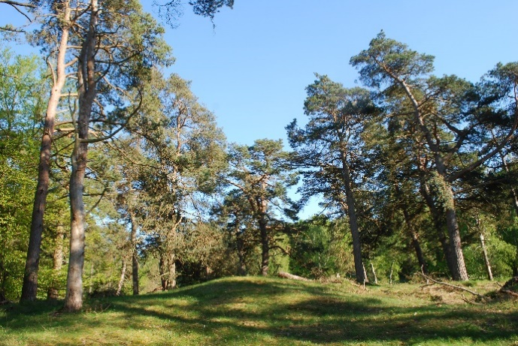

Map: ISOM standard, scale 1:7.500 or 1:10.000, contour interval 2,5 m. Remapped 2018

**Long Final**

The Long distance final will take place in the classic Grib Skov, which is the second largest in Denmark. The terrain is typical for eastern Denmark and yet challenging due to its complex varieties of vegetation - from thick spruce forest to hilly, yet fast old beech forest areas. Despite the fact that felling has been extensive over the previous years, large areas of old spruce still provide for fast running. This combined with a substantial number of lakes and marshes will require rapid route choice decisions. As in Tisvilde Hegn, rapid changes in visibility will test your ability to choose the optimal speed. A difference in height of close to 80 metres - from the shore of Lake Esrum to the abandoned radar station in the central part of the forest - will provide some quite physical challenges as well.

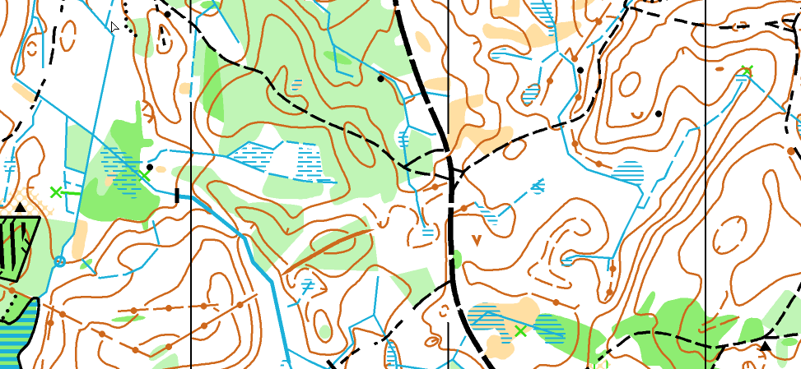 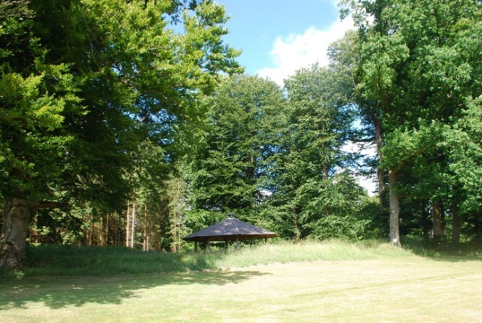

Map: ISOM standard, scale 1:7.500 or 1:10.000, contour interval 2,5 m. Remapped 2018

5/8

**Punching System**

The SPORTIdent punching system will be used. SI-cards can be rented from the organisers by choosing this option in the entry form. The hire charge for the entire week is €15 if booked in advance.  
Without pre-registration the hire charge is €5 for one day or €20 for the entire week.

**Embargoed areas – old maps**

Embargoed areas are shown on the webpage:

<http://wmoc2018.dk/embargo.html>

Old maps of the competition areas: [info@wmoc2018.dk](mailto:info@wmoc2018.dk)

**Clothing**: Competitors can make their own choice of clothing and footwear.

**Antidoping:** IOF Anti-doping rules apply, <http://orienteering.org/anti-doping/>

**Entries and payment**

* Entries will be open from 20th of June at [www.wmoc2018.dk](http://www.wmoc2018.dk)
* It is possible to enter for one competition only (Sprint or forest competitions).
* Entries become valid only after payment of the entry fee.

**Event fees (€)**

|  |  |  |  |
| --- | --- | --- | --- |
| Deadline | Sprint only | Forest only | Both Sprint and forest |
| 28th of Dec. 2017 | 100 | 110 | 130 |
| 28th of March 2018 | 120 | 130 | 150 |
| 1st of June 2018 | 160 | 170 | 190 |

**Changes and late entries**

Changes until 1st of June 2018 are free of charge. Afterwards the fee for a change is 10€.

After 1st of June 2018 late entries are possible if vacancies still exist. Extra fee 30€.

**Cancellation**

Before 1st of May 2018 - 70% refund.

Before 1st of June 2018 - 50% refund.

Afterwards no refund.

**Training possibilities**

Competition held in similar terrains before the WMOC 2018 will be mentioned at [www.wmoc2018.dk](http://www.wmoc2018.dk) with links to the event.

Maps of relevant forests for self-training can be provided by the organisers – contact [info@wmoc2018.dk](mailto:info@wmoc2018.dk).

**Public Race**

A 5-day competition will be arranged in the WMOC 2018 areas taking place simultaneously.

10 courses with free entry. If you enter a class, you will participate in an overall competition.

You can choose less than 5 days.

Entries for all 5 days latest at 1st of June 2018: 80 € for 21-, 50 € for -20.

Single days latest at 1st of June 2018: 18 € for 21-, 12 € for -20

Entries per day after 1st of June 2018 until the competition day: 20 € for 21-, 14 € for -20

Open courses will be offered.

More information: [www.wmoc2018.dk](http://www.wmoc2018.dk).

6/8

**Accommodation**

WMOC2018 offers all kinds of accommodation from classroom floor to luxury hotels. We have agreements with a lot of accommodation providers offering a discount when booking via our website. Prices vary depending on the quality. More information is given at [www.wmoc2018.dk](http://www.wmoc2018.dk)

If you are a group with special requirements send a mail to: [info@wmoc2018.dk](mailto:info@wmoc2018.dk)

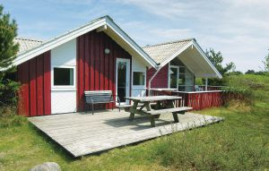

**Food**

Copenhagen and North Zealand offer many different types of foods.

You can have a hotdog from a street kitchen - 3€. Italian restaurants with all from the Italian kitchen – pizza from 7€. Chinese, Thai, American steakhouse, traditional Danish food and of course you can make a reservation at Geranium, a 3* Michelin restaurant, but make the reservation now!

Beer brewing in Denmark has a long history and a great tradition. You can have local beer from minibreweries or a draft Carlsberg, 0,5l from 4€.

**Transport and parking**

For the Sprint Qualification and the forest competitions, transportation from the Event Centre will be possible. This will cost 50€, which covers all these events. For the Sprint Final public transportation is easy, but transport from the Event Centre will be offered for 10€.

When travelling by own transport a parking fee of 30€ will be charged. Buses will be charged 60€ per bus.

This can be requested when registering, or later. Further information will be given at [www.wmoc2018.dk](http://www.wmoc2018.dk).

**Visa**

Coming from EU or Schengen you do not need a visa.

For others find the requirements at:

<https://www.nyidanmark.dk/en-us/coming_to_dk/visa/need_visa/who_needs_visa.htm>

**Insurance**

Each competitor participates in the event at his/her own risk.

**Child care and luggage store**

We can take care of your children and luggage while you are out running. Children must be 3 years or older and nappy free. Enter your need at [info@wmoc2018.dk](mailto:info@wmoc2018.dk).

7/8

**Easy to get to Copenhagen**

From Sweden (and countries with easy access to Sweden) Scandlines from Helsingborg to Helsingør (Elsinore) or the bridge from Malmoe to Copenhagen. From Germany with Scandlines from Rostock or Puttgarden.

Train to Copenhagen central station.

Flight to Copenhagen airport - Northern Europe’s main traffic hub with direct flights from approximately 130 destinations all over the world, including 18

intercontinental, 89 European, 14 Nordic and 6 domestic routes.

**Welcome**

You are only one step away from your participation in a great event – WMOC 2018 in Copenhagen Denmark. Sign up at [www.wmoc2018.dk](http://www.wmoc2018.dk).

See you😊



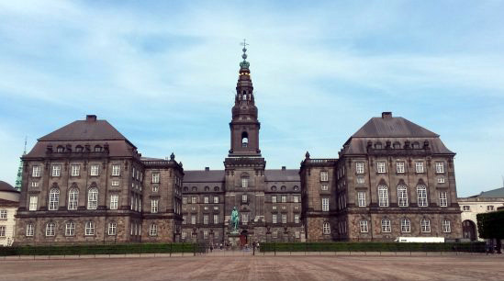

8/8