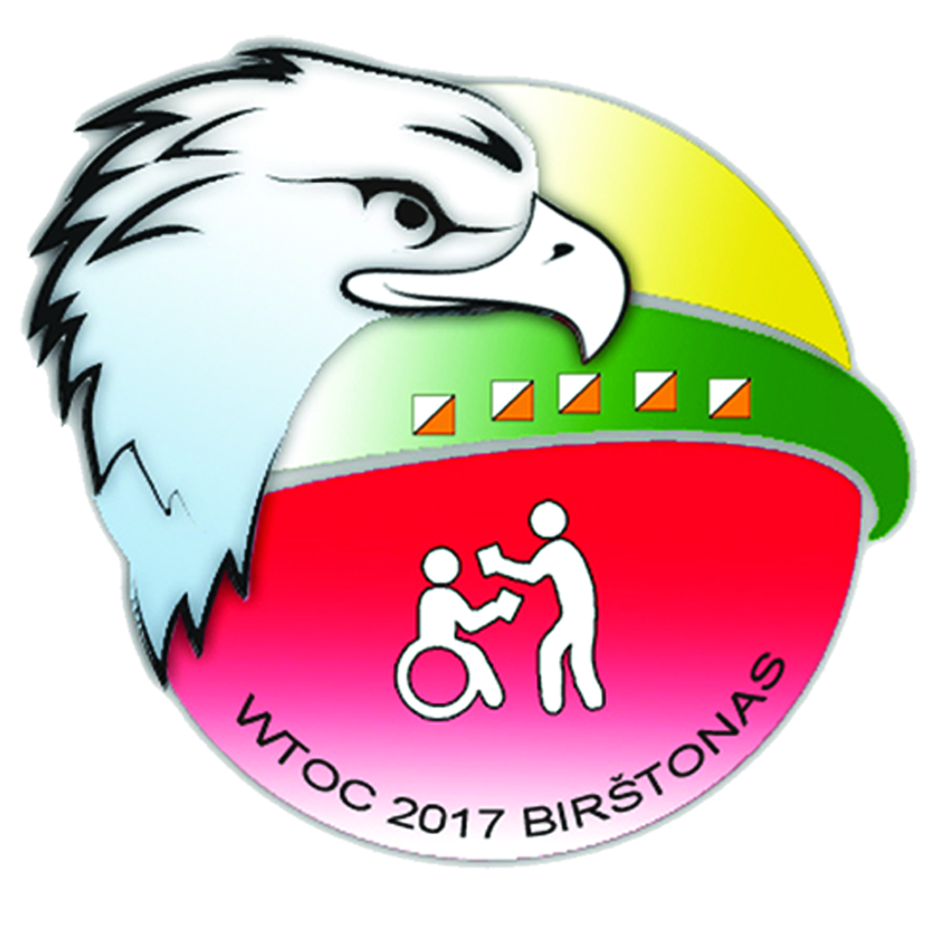
WTOC 2017 Competitor
Personal Information form
There will be commentary again this year, and to make it interesting, information about each competitor is required. Please have each competitor complete this form and return it at the first Team Officials Meeting, or email it to organisers: info@wtoc2017.lt

Federation:
Name (Given):
Name (Family):
Date of birth:
Home town:
Club:
Occupation and any interesting past occupations:

How long orienteering / trail orienteering:

Years represented national team:
Previous best results at national/international level:

Hobbies:

At your discretion, reason for Paralympic eligibility:

Thank you for your cooperation.
WTOC 2017 team

