SYDNEY SPRINT WEEKEND
7 & 8 MARCH 2015

3 top class sprint orienteering races in one weekend!

Urban Sprint Orienteering at its finest. Two complex university campus maps and a new map on sandy bush & park terrain.
This is the opening round of the 2015 National Orienteering League, when Australia's elites kick off their season and race head-to-head in a sprint relay and a Top 40 final. It's also the start of their campaigns to qualify for the world orienteering championships.
Sat Mar 7 (am)  University of Sydney | Sat Mar 7 (pm)  Botany (new map) | Sun Mar 8 (am)  Uni of NSW (mapping in progress)
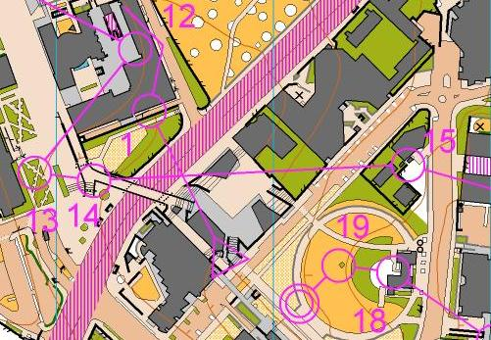 | 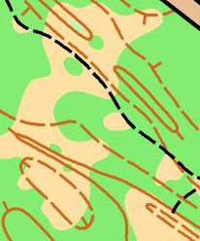  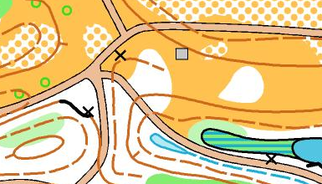 | Sample from the University’s non-O map

For the Elites:
- a World Championship-style 4-person sprint relay;
- National Orienteering League sprint heats; and
- National Orienteering League and World Ranking Event sprint including a ‘Top 40’ final.
For the non-elite orienteer:
- a 2 person sprint relay event
- a NSW State League sprint event;
- the NSW Sprint Championships; and
- a chance to go out on the course and barrack for your favourite Top 40 orienteers.
Plus the excitement of Sydney – Australia’s most fantastic city on the liveliest weekend of the year.
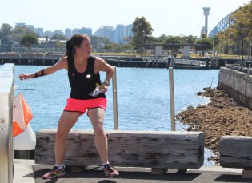
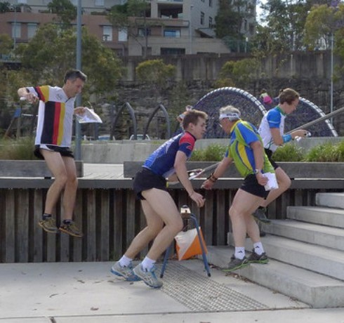
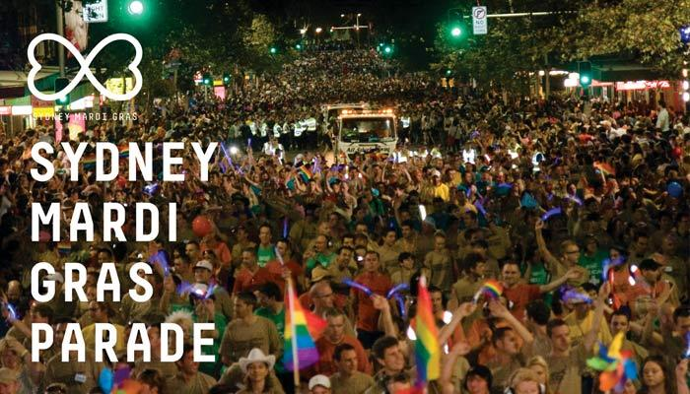
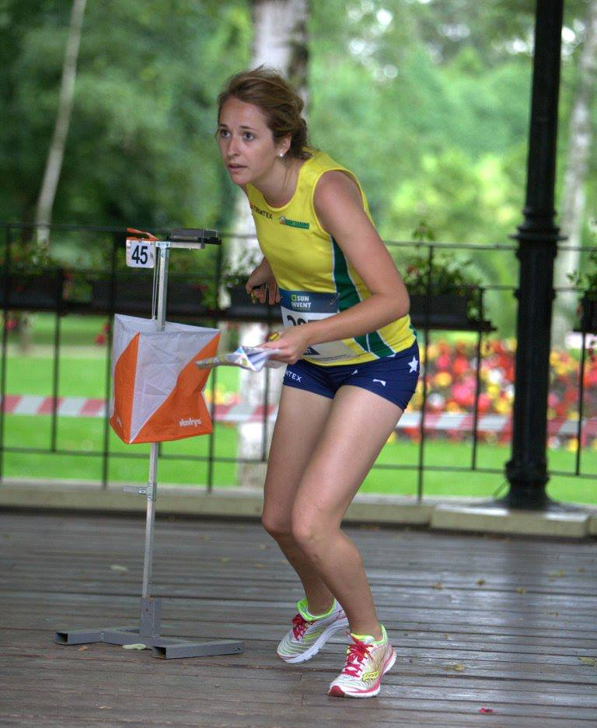

BULLETIN 1 FOR WORLD RANKING EVENT
EVENT INVITATION FOR NATIONAL ORIENTEERING LEAGUE EVENTS

Welcome
Orienteering Australia and Orienteering New South Wales invite orienteers, beginners and spectators to the Sydney Sprint Weekend.

Programme
Please refer to http://www.onsw.asn.au/sydneysprintweekend for the latest information.
Race 1
Saturday 7 March 2015
Morning: University of Sydney, Camperdown/Darlington Campus. Enter via City Road
- 09.00 Start National Orienteering League Sprint Relay
4-person elite sprint relay. Run order: women, men, men, women
- 10.00 Start Public 2 person sprint relay event using the same courses as the NOL relays
- 10.15 Mass start Saturday Orienteering Series easy course
Race 2
Saturday 7 March 2015
Afternoon: Sir Joseph Banks Park, Waratah Road, Botany
- 14.30 First start National Orienteering League Sprint qualification races
Each of the 4 Elite classes will be split into two heats. The top 5 from each heat will compete in the Top 40 race on Sunday.
- 15.30 First start Public races
All Race 2 participants will also be competing in NSW State League event 1.
Race 3
Sunday 8 March 2015
Morning: University of NSW, Kensington Campus, Barker Street
- 09.00 First start Public races
- 10.00 First start National Orienteering League & World Ranking Event
- 11.00 First start Top 40 Race (part of the NOL and WRE)
All Race 3 participants will also be competing in the NSW Sprint Championships (NSW State League event 2).

Location of events
All 3 events will be held within 12km of Sydney’s central business district. The location of each event is shown on the map at the bottom of its Eventor Australia page:
Race 1 University of Sydney, Camperdown/Darlington Campus
Race 2 Sir Joseph Banks Park, Botany
Race 3 University of NSW, Kensington Campus

Terrain
All maps will be mapped in accordance with International Specification for Sprint Orienteering Maps. The two university maps will be 1:4,000 and Sir Joseph Banks Park 1:5,000. Contour interval for all 3 maps will be 2m.
Race 1 – start your Sydney Sprint weekend with a trip to University of Sydney for the Sydney Sprint Relays. Cheer on the National Orienteering League relay teams starting at 9am. Then compete on the same courses in teams of 2 in an exciting sprint relay starting at 10 am. There will be plenty of fast and furious racing with lots of controls and changes in direction!
Students competing in the Saturday Orienteering Series can run in the public relay at 10am or an easy course, in pairs or singly, starting at 10:15 am.
University of Sydney campus has developed haphazardly over 160 years and has a dense but irregular pattern of buildings. It has good route choice and some detailed navigation. It has the reputation of the best campus sprint orienteering area in Australia. Most of the orienteering will be on pedestrian pathways and grassed areas.
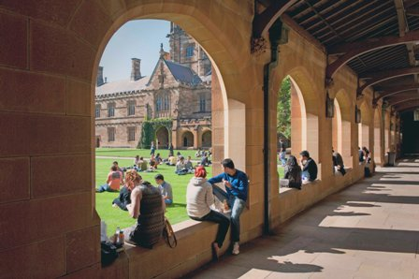
Race 2 - Sir Joseph Banks Park has two types of terrain:
- rough open areas on low sand dunes interspersed with paths running through thick vegetation; and
- parkland with ponds and some low (<10m) hills.
The area is different to any other area in Sydney and presents a new set of high speed, navigational challenges.
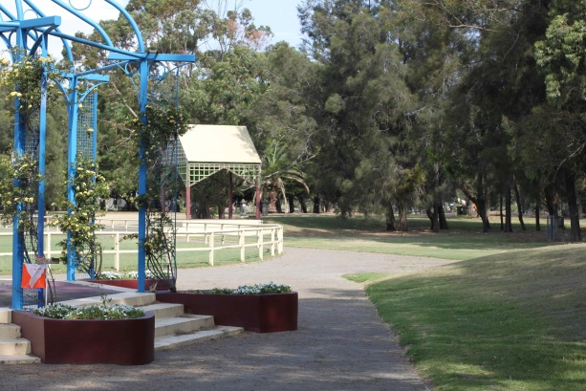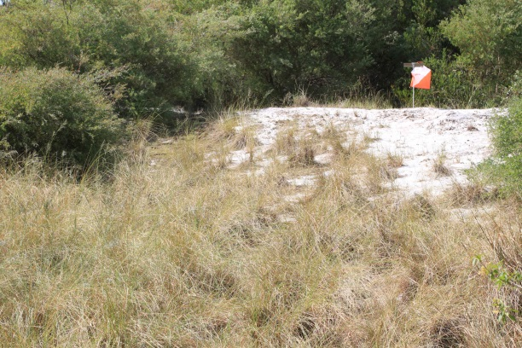
Race 3 - University of NSW is a densely built university campus with a highly regarded landscape and architecture. Most of the orienteering will be on pedestrian pathways and grassed areas. The western part of the campus is flat. The eastern end rises 30m higher. There are many staircases, passageways and canopies. Intense navigation at high speed will be required.
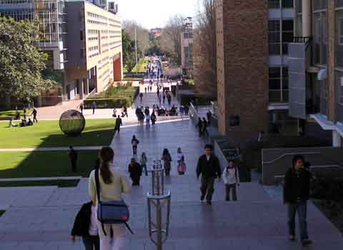
---------
Both university campuses have some low-speed-limit roads that will be open during the events. The organisers will not be stopping traffic for the events, so competitors are responsible for avoiding traffic accidents. The roads are marked with a darker brown than pedestrian paths (see University of Sydney map).

World Rankings, National O League & NSW State League
Elite eligibility
There will be four Elite classes: M20E, M21E, W20E and W21E.
M20E and W20E competitors must be aged under 21 as at 31 December 2015.
World Ranking Event
The World Ranking Event (part of Race 3) is open to competitors in M21E and W21E. M21E and W21E competitors who wish to be eligible for World Ranking Points must provide their IOF ID in accordance with the entry instructions.
National Orienteering League
Race 1 will be a 4-person sprint relay with a starting order of men, women, women, men. There are no classes in the relay. States will be able to nominate as many teams as they wish.
Races 2 and 3 will be individual races, with 4 classes: M20E, M21E, W20E and W21E. M20E and M21E will run the same course. W20E and W21E will run the same course.
Race 2 will have two qualifying heats in each class. The top 5 orienteers in each heat will qualify for the ‘Top 40’ race.
Race 3 – the ‘Top 40’ orienteers will start after all other orienteers. They will be quarantined until they start and other orienteers will be encouraged to be spectators around the course.
Orienteers who did not qualify for the ‘Top 40’ will run earlier on the same course as the ‘Top 40’ runners.
For NOL point scores, the first finisher who doesn’t run the ‘Top 40’ in each class will be ranked after the last finisher in the ‘Top 40’. Team results will be based on the sum of placings.
NSW State League (Orienteer of the Year)
NSW State League Classes at Races 2 &3 are as follows:
W10A, W12A, W14A, W16A, W35A, W40A, W45A, W50A, W55A, W60A, W65A, W70A, W75A, W80A, M10A, M12A, M14A, M16A, M35A, M40A, M45A, M50A, M55A, M60A, M65A, M70A, M75A, M80A
W21AS, W35AS, W45AS, W55AS, M21AS, M35AS, M45AS, M55AS
M/W10N, M Open B, W Open B, M Junior B, W Junior B, Open Easy, Open Very Easy
Points to note:
- Orienteers will score points in the Orienteer of the Year competition, regardless of whether they are members of Orienteering NSW.
- Race 2 - each of W20E, W21E, M20E, M21E will have two heats. Race 2 will not count in the NSW OY points competition in these two classes.
- Race 3 - no 20A or 21A classes are offered. Orienteers in W20E, W21E, M20E and M21E in will score NSW OY points in the equivalent A class.
- Race 3 - due to the complexity of the campus, there will not be a Very Easy course. Shadowing will be allowed on M10A and W10A (which are NSW Championship classes and will count for OY points), as well as M/W10N.

Entry
Entry is available on the Australian Eventor website. Entries close 20 February 2015 at 23:59.
Entry Fees
Junior fees apply to M/W14 - M/W20.
Sub-juniors are M/W10 and M/W12
Sportident hire is $4 per entrant, per race

Race 1 – University of Sydney - sprint relays
National O League relay (per person): $25 senior, $22 junior
Public relay & easy Saturday O Series course (per person): Senior $15, Junior $12, sub juniors $10
Race 2 – Sir Joseph Banks Park – National O League & NSW State League
Senior $22, Junior $15, Sub Junior $11, family Discounts apply

Race 3 – University of NSW – National O League and NSW Sprint Championships
GARINGAL TO ADVISE FEES
-----------
If you have not used Australian Eventor before, you will need to register before you enter. For Help on How to Register, see ONSW’s Event Calendar page.
To avoid making more than one payment, you should tick all the events you wish to enter on the calendar before clicking to the next page.
Enter on the day starts will be available at the Public Races, but only one course will be on offer and maps will not be printed on plastic paper.
M21E & W21E Competitors in Event 3 (World Ranking Event)
M21E and W21E competitors who wish to be eligible for World Ranking Points must provide their IOF ID. You do this by entering your 5 digit WRE number in the Order Services part of the Eventor entry.
If you don’t remember your number or are not sure if you have one, you can check the IOF’s Athlete’s list. Competitors who do not already have an IOF world ranking ID must request one using the template available on the IOF’s World Ranking Instructions.

Organisation

Event | Sprint relay  Race 1 | NOL qualification & State League sprints  Race 2 | NOL finals/WRE & NSW Sprint Championships  Race 3
Organising club | Big Foot | Uringa | Garingal
Event Organiser | Jo Parr | Ron Pallas | Rod Eckels
Course Planner | Jayne Sales | Matt Peters | Ross Barr
Controller | Cath Chalmers | Dick Ogilvie | Andrew Lumsden
Mapper | Andrew Lumsden | Dave Lotty | Ross Barr
Field check | Cath Chalmers | Alex Tarr &  Matt Peters | Andrew Lumsden
Event Director: Andrew Lumsden
Overall Controller: Nick Dent
IOF Event Adviser for the World Ranking Event: Nick Dent (Australia)

Event Centres
There is no event centre. Chest number collection (elites only), Sportident card collection, entry on the day and any other enquiries can be made at the registration table at each event.

Access to the terrain
The IOF and Australian Rules say:
26.5 Any attempt to survey or train in the competition terrain is forbidden, unless explicitly permitted by the organiser. Attempts to gain any information related to the courses, beyond that provided by the organiser, is forbidden before and during the competition.
The organisers have determined that prior to the event:
- Sir Joseph Banks Park is fully embargoed;
- University of Sydney, Camperdown/Darlington Campus and University of NSW, Kensington Campus - access is permitted for non-orienteering reasons. Use of orienteering maps, training of all kinds and route-choice testing is not allowed in these areas. People who normally train from their place of work or home in the campuses may continue to do so, following their normal routes.

Acquaintance with the terrain or map
The IOF and Australian Rules say:
26.6 The organiser shall bar from the competition any competitor who is so well acquainted with the terrain or the map, that the competitor would have a substantial advantage over other competitors.
The organisers are aware that some orienteers have worked or studied on the campuses. The following information is provided to minimise any such advantage.
Information on the three areas
The maps of Sir Joseph Banks Park and University of NSW are new and will not be used before the Sydney Sprint Weekend.
There is a variety of information available from various search engines. Google Earth has georeferenced photos of parts of each area.
SIX Maps has aerial photos that are generally more up to date than Google Maps. It also shows topographic maps.
Race 1 - University of Sydney, Camperdown/Darlington Campus
The existing map of the university will be used for the 7 March events. Copies of the map can be seen at:
5th January 2014 event
20th January 2013 event
The University website provides campus maps and a list of places of interest. Photos of the main buildings can be found on the Lost on Campus website.
Race 3 - University of NSW, Kensington Campus
The University website provides a map and a virtual tour of the campus.

Competition Rules
The Competition Rules for IOF Foot Orienteering Events apply at the World Ranking Event.
The Competition Rules for Orienteering Australia Foot Orienteering Events apply to the National Orienteering League events. These are very similar to the IOF Rules.
Orienteering NSW’s Competitor’s Rules apply to all events in the Sydney Sprint Weekend. These Rules contain some additions to OA’s Rules and are used by Orienteering NSW to ensure orienteering is conducted safely and to manage its land owner and public liability risks.

Punching System
SPORTident punching system will be used for all events. Athletes may use their own SI Cards. SI-Cards will also be available for hire if necessary.

Winning times
Estimated winning times for all races are 12 to 15 minutes.

Travel, accommodation and food
Sydney is the largest city in Australia. Sydney Airport, Central Railway Station and bus terminal are less than 10km from each of the events.
Visitors from some countries require visas to enter Australia. Please check with your travel agent or visit www.immi.gov.au/Visit/Pages/Visit.aspx.
The Sydney Destination website lists over 600 accommodation options at all price levels.
The 2015 Sydney Mardi Gras Parade will be held in the evening of Saturday 7 March. This is a major event, with around 300,000 spectators, so flights and accommodation will be heavily booked.
Sydney has a huge variety of food options including at least 5,194 restaurants. Catering options at the Sydney Sprint Weekend events are being investigated.
Orienteering NSW will try to arrange billets for non-Sydney based orienteers. Please email admin@onsw.asn.au if you are interested in being billeted.

Event Transport
Competitors are responsible for their own transport to and from events. Competitors who do not drive their own cars have a choice of public transport, taxis or rental cars. Taxi fares can be estimated at using the Taxi Fare Calculator.
It is possible to reach each event by public transport. Use the Transport NSW website for more information. The event programme (Bulletin 2) will provide more detail of how to use this website.

Clothing Restrictions
Spiked shoes or shoes with metal cleats are prohibited at the two University campuses. Racing flats and shorts are suitable for all races, although there is some scratchy vegetation at Sir Joseph Banks Park.
Competitors are unlikely to run on a bearing in any of the 3 races, so a compass is not essential. Control descriptions will be available on the map and loose at the start. Control description holders and Southern Hemisphere compasses are available for sale from Aussieogear.

Weather
A summary of weather conditions for March is:
Record high | 40° C
Average high | 25° C
Average low | 18° C
Record low | 9° C
Ave rainfall for the month | 130mm
Ave rainy days in month | 13.6
Ave % humidity | 62
Australia’s Bureau of Meteorology forecasts for Sydney are generally reliable.

Insurance and risk waiver
Competitors participate in the Sydney Sprint Weekend at their own risk. No health, accident, ambulance, disability or life insurance is provided.
You will need to agree to Orienteering NSW’s entry terms and conditions before you can enter the events.

Media
We welcome all media representatives to the Sydney Sprint Weekend. For information please contact: Ian Jessup, Marketing & Communications Officer, 0416 040 135 (in Australia) or 61 416 040 135 (other countries) or marketing@onsw.asn.au.

Information
For further information please see the Sydney Sprint Weekend webpage or contact:
Race 1 | Jo Parr | jomp@optusnet.com.au | 612 9487 4287
Race 2 | Ron Pallas | ronpallas@hotmail.com | 612 9526 6229
Race 3 | Rod Eckels | rod@slekce.com | 612 8084 5524
Elite matters | Nick Dent | nickdent7@gmail.com | 612 4384 3627
Entry enquiries, how to use Eventor, Billeting | John Murray | admin@onsw.asn.au | 612 8116 9848

Bulletin 2 will be published in February 2015.

